Table of Contents
1 Introduction 3
1.1 Problem Statement​ 3
1.2 Solution​ 3
1.3 Document Purpose 3
2 Testing Assessment 4
3 Testing Summary 5
3.1 Test Overview 5
3.2 Test Type (User testing) 5
4 Approvals and Signoff 10

Introduction
The data & Reporting project will focus on the development and implementation of a ‘Operational Data Storage’ (ODS), developing tactical reports to replenish the reporting requirements known for business sectors within Emerge Aotearoa and then embark on the mission of building an ‘Enterprise Data Warehouse’ (EDW) to fulfil all future reporting requirements.

Problem Statement​
The business requires reports and insights from the financial data held in Business Central.​
The original recommended approach to extract data relied on a 3rd party product called Cloud Replicator from a company called eFoqus.​
Due to an uncovered issue on the Azure platform, this product has been failing, resulting in additional workload being required on the data platform (Storage & ODS). With no known fix timeline, this solution will remove the reliance on Cloud Replicator and the requirement it has for CosmosDB, replacing both with components from the existing data platform.​
​
1.2 Solution​
We change the ingest data process from the Business Central API instead of Cloud Replicator and CosmosDB .This will require testing of ODS data

Document Purpose
The purpose of this document is to capture the testing scenario approach and Sign off Process.

Testing Assessment
Data extracted from the Business Central source system to ODS is straightforward without transformation. We need to verify basically
- Record count matches between BC and ODS for required tables.
- There is no duplicate record loaded in ODS
- There is no truncation happening for the dataset.
- There is no null value captured against a not null column.
- Chart of Account data is the primary source for user Testing
- Income statement /Balance sheet data must match between BC and ODS

Testing Summary
In the above test scenario, Test cases 1-4 have been tested by Vendor and Emerge BI Team .5, and Business users test 6

Test Overview
Chart of Account report from BC and ODS data compared for all companies for the Period of
1-July-2023 to 30-Sept-2023. The Finance Team has Provided Test data from business central for said Period.
A PowerBI Test Report is developed and communicated to the user. Below is the link for the same
https://app.powerbi.com/links/4LFB7kOwHI?ctid=961a9ce6-4d38-452f-9d9d-26942599bbe0&pbi_source=linkShare&bookmarkGuid=e8fb13e7-72aa-4f51-92a9-a080427bd86b

Test Type (User testing)
EAL Testing
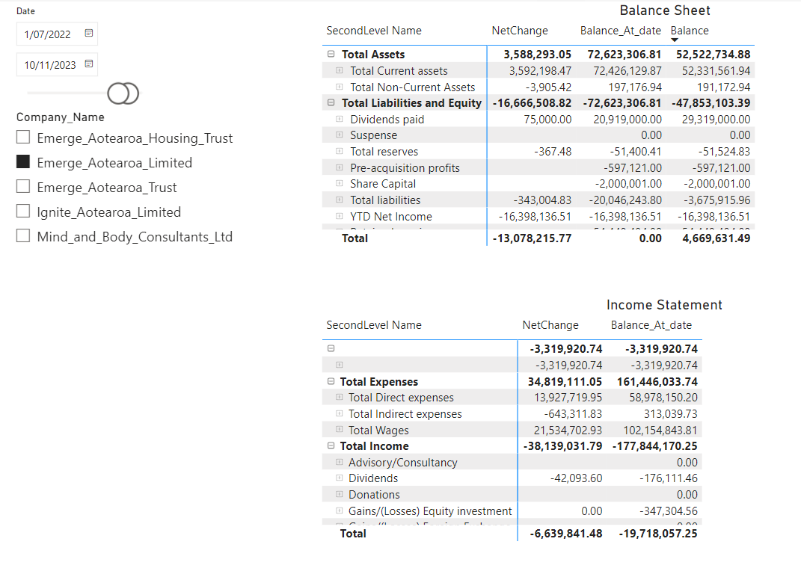
EAHT
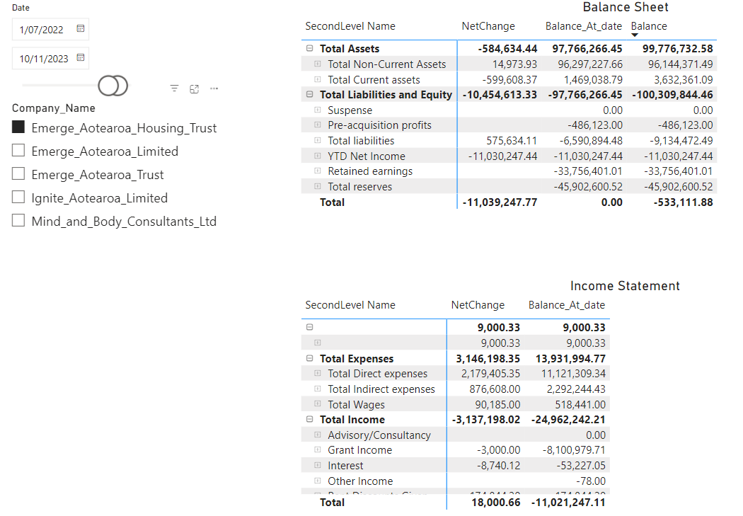
EAT
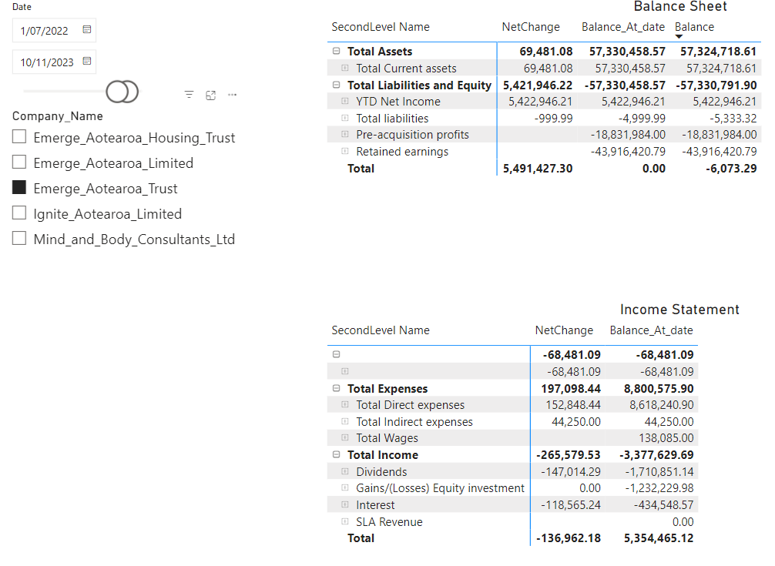
IAL
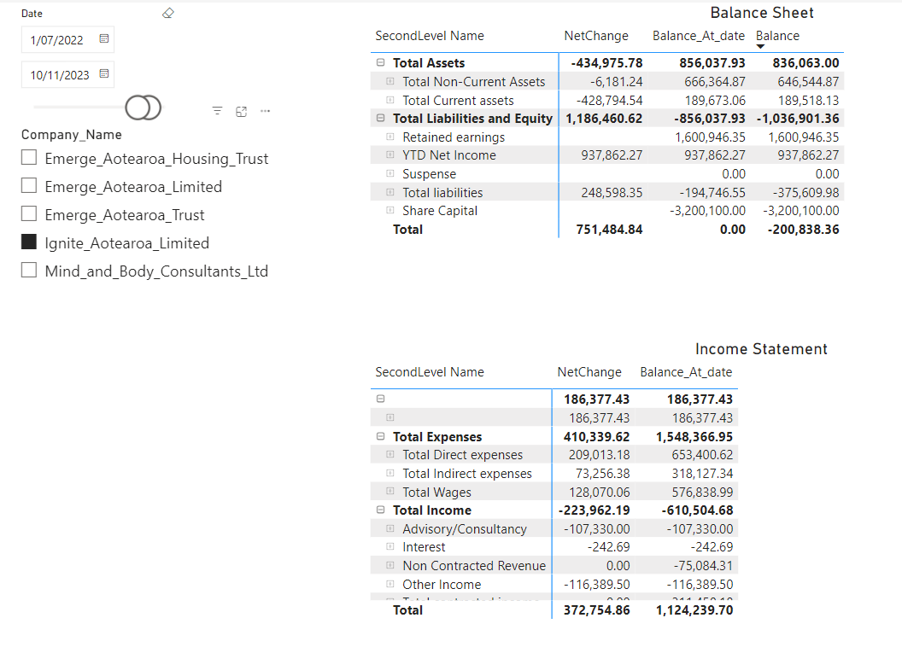
MNB
